Test Name: M-TEMP Sensor Quality Assurance Testing - Indoors

Date: 9/16/24

People involved: Andrew, Ruudy

Description:

To ensure the accuracy of the data from our cart sensors, we operated both carts side by side. This setup allows us to closely examine the sensor data for any anomalies and use the comparison between the two carts to validate the results. Both carts were set up inside Room 130C.

Sensors and Set Up:

********Cart 1 - USB-TEMP DAQ {AI0: 1.8 ft (°C), AI1: 5.4 ft (°C), AI2: 0.0 ft (°C), AI3: 3.6 ft (°C),

AI4: 7.2 ft (°C), AI5: 9.0 ft (°C), AI6: 3.6 ft b (°C), AI7: 5.4 ft b (°C)}

USB-1208FS-PLUS DAQ {AI0: IR Raw (V)}

********Cart 2 - USB-TEMP DAQ {AI0: 5.4 ft (°C), AI1: 1.8 ft (°C), AI2: 0.0 ft (°C), AI3: 3.6 ft (°C),

AI4: 3.6 ft b (°C), AI5: 5.4 ft b (°C), AI6: 7.2 ft (°C), AI7: 9.0 ft (°C)}

USB-1208FS-PLUS DAQ {AI0: IR Raw (V)}

Location of Stored Data:

[Can be found here in the uc.environmental.frontiers google drive](https://drive.google.com/drive/folders/1-YcXnK4qS8VLDx8oaGt37wq07O2nTOdi?usp=sharing)

Code Used for Processing Data:

[Code for processing data can be found here](https://colab.research.google.com/drive/1tFTUjNy6ZqXY79iQd8tMzmBY1kzuo6Ht?usp=sharing)

Problems or Concerns:

* First time running through the testing, after redoing all the DAQ software, we forgot to adjust the sample rate which resulted in only the last 16 minutes of testing being sampled on both carts. Data could still be useful to look at.

* When trying to start the next test, the DAQ for cart 2 does not seem to be working. Multiple laptops have been used and their DAQAmi software does not detect anything from the cart. Laptops worked when connected to cart 1.

* Test was reran with only cart 1

Other Notes:

* Test 1 Start Time - 10:05 AM

* Noticed you can rename all the AI ports in the set up for each DAQ,

went and did that, this eliminates some lines of code and mental load

from having to remember what is what.

* Thermocouple is reading 23.6 and is situated along side the 5.4 ft sensors

* Handheld IR sensor is reading at 23.9 under Cart 1 and 24.2 under Cart 2

* Test 1 End Time - 11:05 AM

* Thermocouple is reading 25.4

* Handheld IR sensor is reading 24.6

* Test 2 Start Time - 2:09 PM

Conclusions About the Data:

Sensors seem to be working, no incredible spikes, seem to be in working order. The a vs b comparisons are a bit concerning, one would think they would be more similar.

Test 1 Results

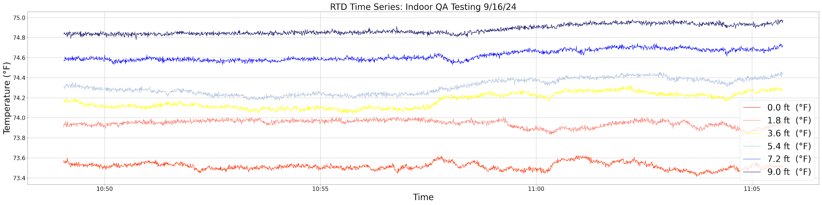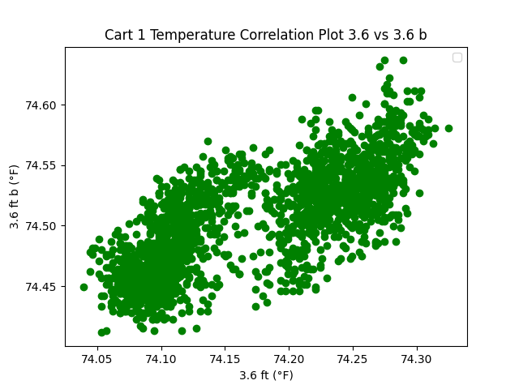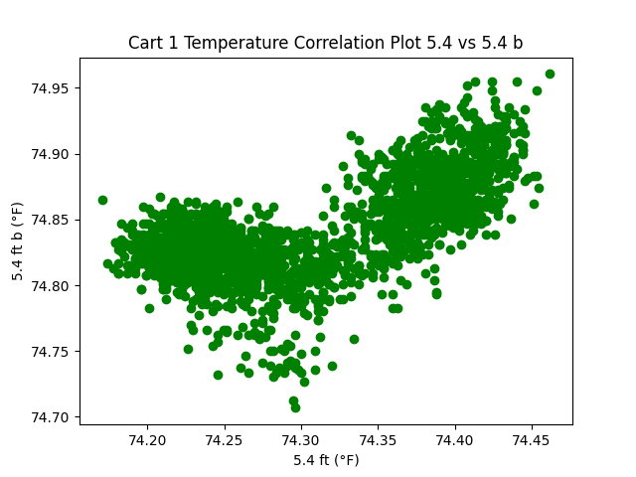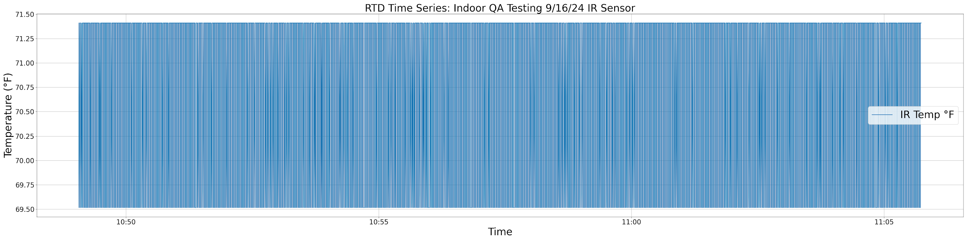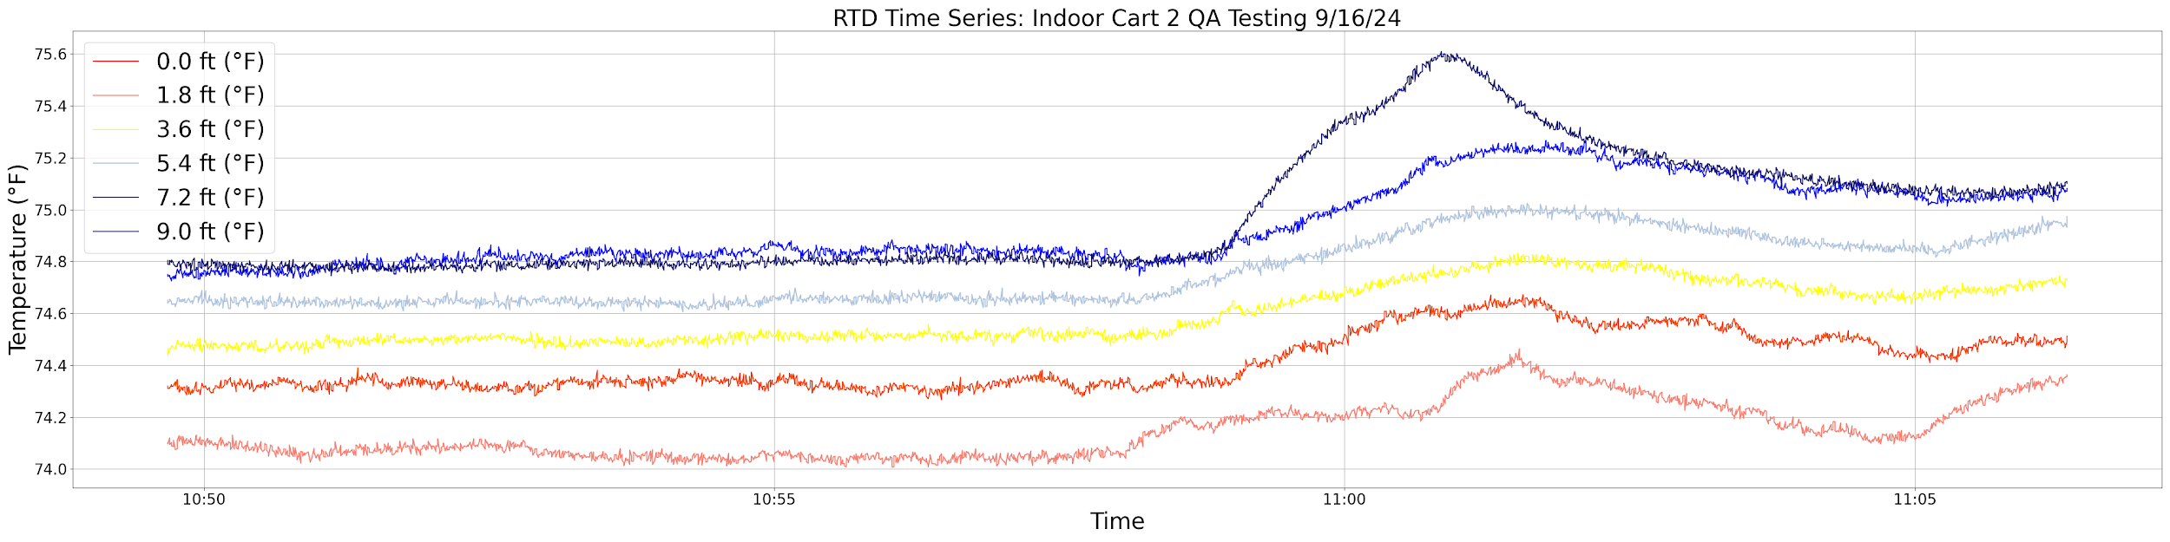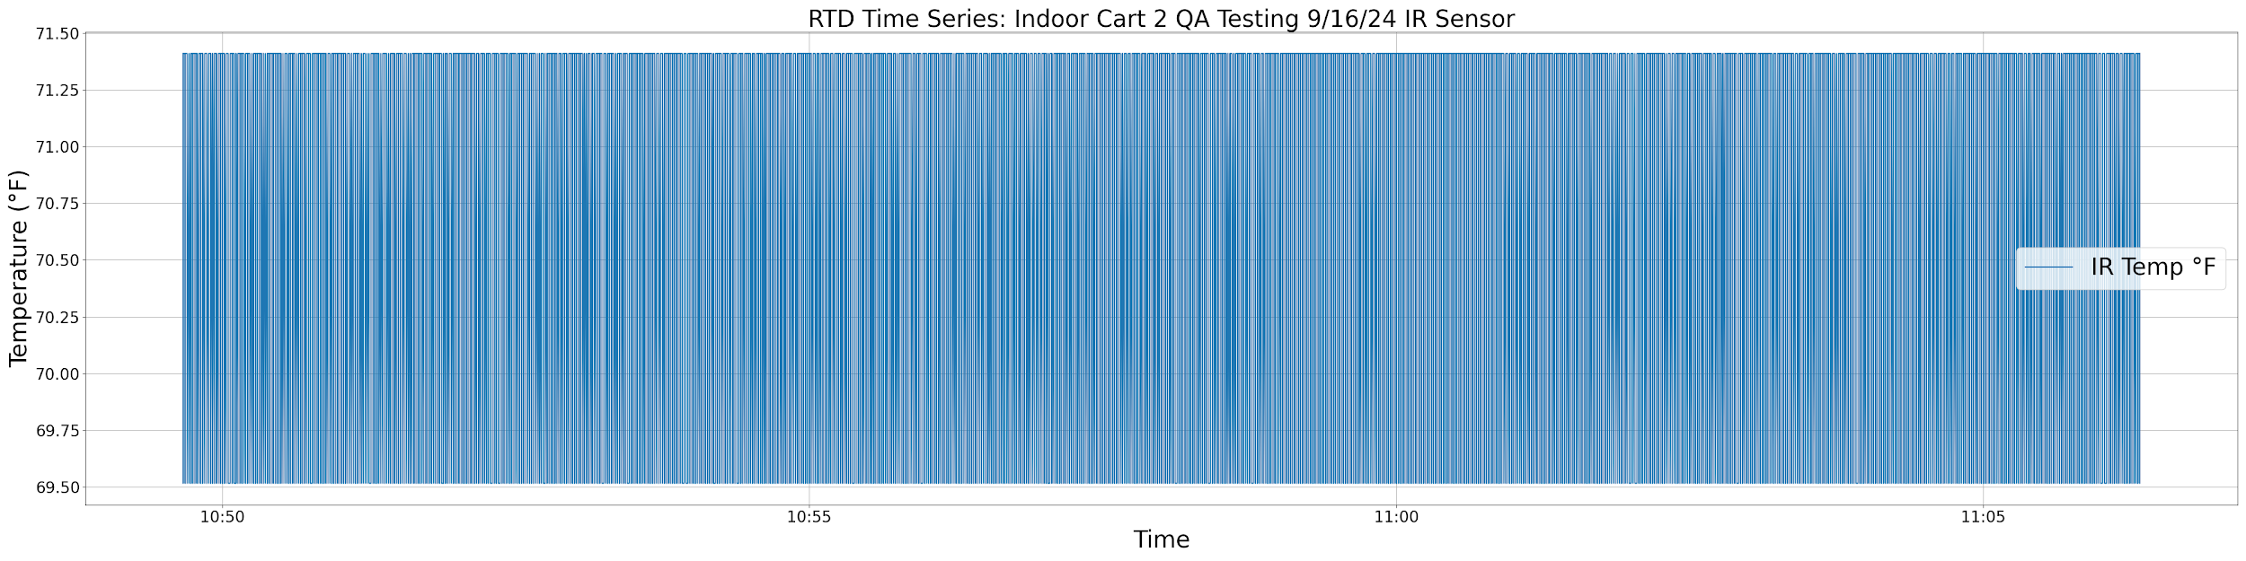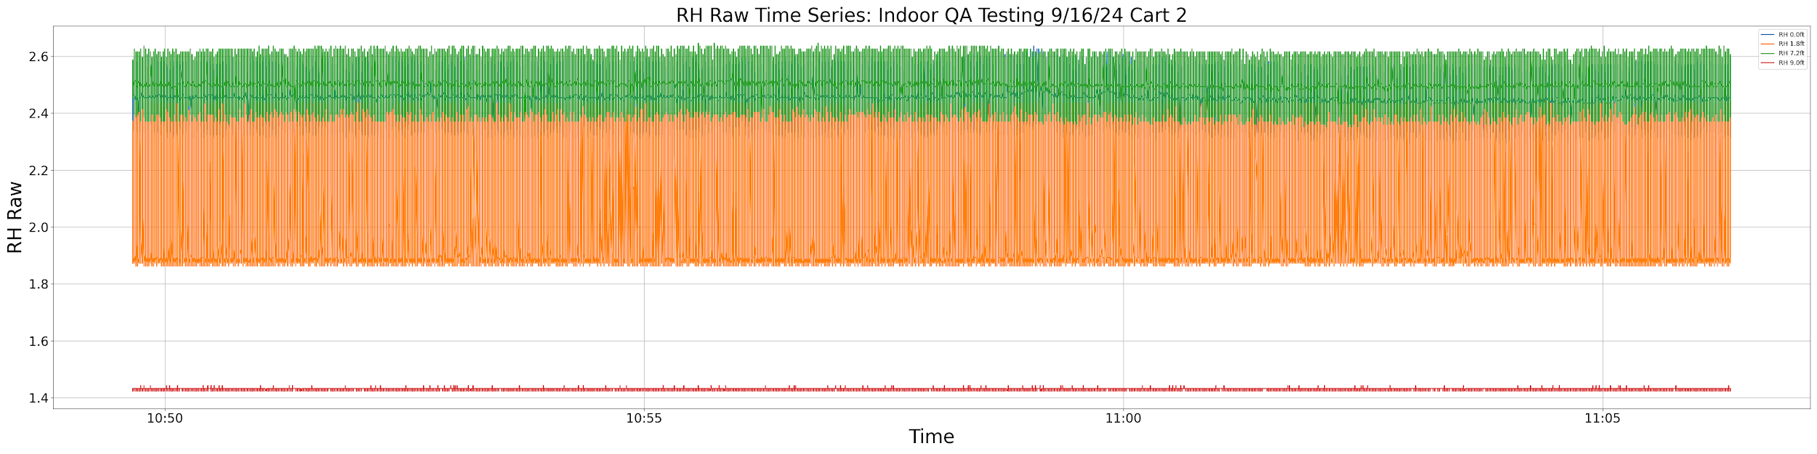

Test 2 Results

